Physics Documentation
Class Diagrams are on UML.pdf, so the image can scale nicely for looking at each class.
Third Party libraries
Only one third party library was bootstrap; it was used in the creation of the physics simulation. The bootstrap library includes functions for drawing lines, primitives and textures of our choosing. It also includes the glm library which handles the vector math needed for some of the collision detection and resolution implementations.
What is the physics simulation simulating?
The physics simulation is representing a basic game of pool with striped balls and full colour balls, to simplify the game I made half the balls red and half the balls blue, however game logic wise it is the same as the normal game. There is one white ball and one black ball, the player shoots the white ball into the other coloured balls to try and hit them into one of 6 sockets around the pool table, the player who sinks the first coloured ball will then be that colour and the opposite player will be the other colour. If the player sinks the white the other player will have the option to place the white wherever they want in the leftmost third of the table. The player will win when they sink all 7 of their balls in then the black without sinking the white on the same turn. If the other player sinks the black early or sinks the white with the black for the win, the opposing player wins.
Types of physics objects:
We have 3 types of objects in the engine currently.
Static
Static objects are physics objects with theoretically infinite mass and are functionally immovable by collisions, they still resolve collisions with dynamic objects when collisions are detected. When resolutions are called the elasticity of the object is taken into consideration to calculate the amount of velocity to absorb from the colliding object, these objects are mostly used for walls, obstacles and planes to keep a player in the game space.
Some objects are only static such as planes, as they do not move and have a set position.
Dynamic
Dynamic objects are physics objects that have physics forces applied to them, such as gravity, momentum, etc. These objects have individual resolutions for each collision (such as sphere to sphere, box to box etc.). Which resolution to call is calculated by the collision detection. Each resolution function will affect the position and velocity for both objects, the total momentum that the collision absorbs is determined by a factor of elasticity between both objects, the total momentum is calculated by the addition of the two objects velocities. These objects are used for anything that requires real time physics interactions.
Triggers
Triggers are used as colliders only. Triggers have a shape (bounding box, sphere, mesh etc) that when collided with by a dynamic object, a on enter function is called. When the colliding object has left the bounds of the object a on exit function is called, depending on the setup of the trigger system, the on enter function may be called every frame the colliding object is inside the bounds of the trigger, more commonly the trigger will have a on enter, on stay (called every frame object is inside) and a on exit function. Our implementation has defined an on trigger enter function and an on-trigger exit function. This object does not have collision resolution at all as it does not affect the velocities or positions of itself or other physics objects.
Rigid bodies can be static (otherwise known as kinematic), dynamic or triggers, as they are primarily made for physics interactions, Rigid bodies by default are dynamic objects.

Collisions:
Sphere:
SphereToPlane:
To check the collision on a sphere to a plane we must project the center position of the sphere onto the normal of the plane, this is done with the dot product, once we have this length, we minus that value by the plane’s distance from the origin which gives the distance from the sphere to the plane.
We then take the radius of the sphere and minus it by the plane to sphere distance, we do this so if the distance is positive or negative it will not change the result, this result gives the amount of intersection between the plane and the sphere.
We then perform a dot product on the sphere’s velocity and the planes normal, this allows us to check if the sphere is already going to leave the plane before applying more force.
If the intersection is more than 0 and the sphere velocity dot product was negative (facing more than 90 degrees in the opposite direction) then it has collided, we then call the collision resolution.

SphereToBox:
Detecting a collision between a sphere and a box requires us to transform the spheres position into the box’s coordinate space.
We do this by getting the vector between the box’s center and the center of the sphere.
We then project that vector onto the box’s LocalX and LocalY (so the rotation is considered), we will call this the circleboxpos. with that we then clamp circleboxpos by the extents of the box.
We do this by checking the x and y positions of circleboxpos against the half Lengths of the box in positive and negative. If it is less than or greater than the extents, we make the x or y equal to the extents.
This gives us the closest point on the box to the sphere, we then convert that closest point back into world space by scaling it with the box’s LocalX and Y vectors.
Lastly, we get the distance from the closest point on the box to the spheres center. We minus the sphere’s radius by the length. If the result is greater than 0 then the sphere is colliding, and we then call the collision resolution function.
SphereToSphere:
To see if two spheres are colliding, we get the distance between the two sphere’s centres and then check if that distance is less than both of their radius’ added together, if it is then they have collided.
Box:
BoxToPlane:
Checking a plane to box collision requires us to check each corner of the box. We also want to get a representative point on the plane, this is done by multiplying the planes distance from origin by its normal.
From there we get the world space of each corner by multiplying the corner by the LocalX and LocalY (for rotation) of the box + the box’s center position.
We get the distance from the corner to the plane by performing a dot product on the corners world position minus the planes point and the planes normal. We then get the displacement from the center of the box to the corner by multiplying the corner with the box’s LocalX and LocalY.
We then need to know if the current corners velocity will continue to collide with the plane or if it is already moving away from the plane, this is to stop the box from having forces applied to it multiple times, we get the corners velocity by adding together the box’s velocity and the box’s angular velocity, then multiply the result by the perpendicular vector of the displacement from the box center to the corner.
With this corner’s velocity we then use the dot product of the planes normal and the corners velocity to see how similar in angle the two vectors are, if the dot product returns a negative number or zero, we know the corner is going to continue to collide or move perpendicular to the plane.
We then check if the distance from the plane we got earlier is less than zero and the corner velocity check is less than or equal to zero, if this returns true then we know that the box is colliding with the plane and that a collision resolution needs to occur.
BoxToBox:
For detecting a box-to-box collision we must project one box onto the other to check if any of their corners (or the whole box) has collided.
We do this by looping over each corner of one box and transforming each corners world position to the second boxes local space, this is done by getting the distance vector from the box’s center to the current corner being checked, the distance vector is then used to get the x and y values, x will be equal to the dot product of distance vector minus the box center position by the localX variable of the box and the y will be the same but with the localY variable instead of the localX.
We then find the extents of the second box, this is done by checking each corners position and checking if the x and y is greater then or less than the current extents, if its true then we update the extents.
Once the second box’s extents are updated, we check if the corner is in the first box’s extents range. We check the point position against the most left and right x and the highest and lowest y of the box, if the point is in that range then we know it has collided and we add one to the number of contacts and add the position to a vector two to then average it to apply the force in the collision resolution.
We then check the second box extents that were calculated earlier. With this we check the second box’s extents against the first box’s extents so see if a separating axis has occurred. If it has then we can exit with false.
If this collision is not a separating axis and the number of contacts is not zero then we can continue and get the world space of the collision, this is done by adding the local contact variable by the boxes LocalX and Y respectively then divide that vector by the number of contacts the box must find the average collision point.
We then find the penetration amount and normal of the collision. As by this point its known that a collision has occurred, we now want to find the minimum penetration vector as a penetration amount and use the corresponding localX/Y box normal as a collision normal.
We do this by getting the first box’s extents minus or plus the max or min of the second box extents we calculated before. We check extent against each other and if the penetration amount is less then one calculated before then that is the new penetration amount and the normal becomes the localX or Y in negative or positive depending on the check performed.
We put the above box collision test in a check box corners function with the penetration, collision normal, number of contacts, contact position and the minx/y and the max x/y outside of the function to be able to keep all that information to be used in the collision resolution.
However, this is abstracted out so the function can be called twice as to find the smallest penetration we first run the checkboxcorners function with box two projected to box one, and then run the function again but yeah box one projected onto box two. Then once those checks are done if the penetration is less than or equal to 0, we know a collision has not occurred, if this is false then we call the collision resolution function.
Overlap Functions
As with the other overlapping functions, we take in the arguments and swap them as needed to call the function that has already been defined for this collision. For example, BoxToSphere will call the SphereToBox function and put in the required arguments.
Collision Resolution
Plane resolution:
As the plane is a static object in the engine the collision resolution only needs to apply forces to the object that collides with the plane.
To resolve this collision, we need to get the point of contact for applying the force to the colliding object, which is obtained from getting the contact point (supplied by the collision detection algorithms) minus the colliding objects position.
Next, we get the relative velocity of the object which is its directional velocity + its angular velocity * the perpendicular vector of the contact point. We get the amount that the relative velocity goes into the plane by using the dot product on the relative velocity by the normal of the plane.
To find the perpendicular distance to apply relative to the center of mass of the object to calculate the torque that will be added by this collision we get the dot product of the local contact by the right perpendicular vector of the planes normal. We will call this value R.
Using this information, we can calculate the effective mass of the object so we can then apply forces correctly, we get this by the following formula
mass = 1 / (1 / objectCollidingMass) + (R * R) / objectCollidingMass
From that effective mass formula, we get the impulse amount to apply which is defined as the formula
-(1 – objectCollidingElasticity) * velocityIntoPlane * effectiveMass.
With our impulse force we can calculate the force to apply to our object which is our planes normal multiplied by the impulse force. From that we then apply force to the object with the arguments force, local contact.
Because of contact forces (making sure that if the object has collided it does not look like its half in the plane) we get the length from the plane to the contact point which is dot product of contact point and the plane normal. To get the distance from that we than minus the result by the planes distance to origin.
From that dot product we than call the applycontactforces onto the object colliding with the plane with the object to apply the force to, the plane normal and the amount of penetration that we just calculated.
Rigid body resolution:
For the rigid body to rigid body resolution, we want to apply equal forces based on their mass and elasticity. For this we first register that the two objects are inside each other this frame (this is for if the objects are triggers to call the trigger function). If one rigid body is kinematic (static object) then we only apply the force to the rigid body colliding with it.
We then want to find their collision normal.
If the collision normal is provided by the collision detection function we use that, if it is nullptr then get the position of the object that this rigid body had collided with and minus it by this objects position. To then get the collision normal get the perpendicular vector of the collision normal.
We then get the radius for each object
For the object calling this function the radius is dot product (contact point – position, -perpendicular Collision Normal). This is radius1
The second object is almost identical dot product (contact point – position (of second), perpendicular collision normal). This is radius2
From there we can calculate the velocity of each object. Vel1 is first Vel 2 is second.
Object calling this function: dot product (velocity, collision Normal) – radius1 * its angular velocity
Other object: dot product (velocity (this objects), collision Normal) + radius2 * its angular velocity
If vel1 is less than vel2 then we know they are moving away to each other and we can choose to not apply any extra force.
If vel1 is greater then vel2 then we must then apply forces to resolve
First, we calculate the effective mass of the two objects
Mass1 = object calling the function: 1 / (1 / object mass + (radius1 * radius1) / moment of inertia
Mass2 = Other object: 1 / (1 / object mass + (radius2 * radius2) / other objects moment of inertia
We then get the elasticity of the collision which is both objects elasticity added together divided by two.
We then can get the impact force now that all these calculations are done. The impact force is defined by the
Impact = (1 + elasticity) * mass1 * mass2 / (mass1 + mass2) * (vel1 – vel2) * collision normal.
Now that we have the impact force we check to see if the objects are triggers in which case, we do not apply forces to them, only call the trigger enter functions.
The checks we want to run is if the object calling the function is not a trigger and the other actor is not a trigger then we can apply force to them.
We call the apply force function to the object that is calling the resolution with the arguments -impact and contact position – objects position, the reason we apply – impact is to that the object colliding goes the opposite direction to what we make the other object go. the other objects force to be applied is impact and the contact position – its position
If one of or both objects are triggers, then we add each object to each other by the trigger enter function, also no forces will be applied to either as triggers do not have collision resolution.
The last step we want to take in our collision resolution is if the penetration variable from the collision detection functions is still above 0 then we want to call apply contact forces with the arguments of this object, the other object, the collision normal and the amount of penetration.

Improvements that can be made to the physics engine:
Awake and asleep:
We can apply awake and sleep states to each physics object in our scene. We do this by checking the velocity of each physics object and if it is lower than a set threshold, the velocity will be set to 0 and then the object will be set to sleep. This will improve the speed of the engine as currently every physics object is calling for collision detection against every other physics object every update call. By adding awake and sleep we can instead run collision detection from each awake object by every object. In simulations such as pool this can reduce the number of checks drastically as after the initial break most pool balls will not be moving per shot.
Object pooling:
We can use object pooling to limit the memory usage of the engine and to reduce the number of objects that need to be created repeatedly. Object pooling is done by having a check to see if the object needs to be deleted or removed from the scene for example when an enemy dies or a pool ball gets sunk. Instead of deleting the object and remaking it when resetting the game or spawning another enemy, we can set the object back to the default settings, such as a pool ball having 0 velocity and being in a position of 999,999 so it cannot be seen. But when needed by the game again we can just set it to where we need and so instead of making another object only a few vectors need to be changed.
Quad trees:
We can add quad tree functionality to the engine as well to reduce the amount of collision checks are necessary. This is done by dividing the scene into grids, at first divide the scene into 4 squares of equal size, as each grid has more objects inside it, we divide that grid point the same as we did for the initial grid (into 4) and so on and so forth until either further sub dividing is not needed, or we reach a set limit of layers. The reason we do this is so that we only check for collisions in that grid. for example, we could have 10 objects in one grid but 300 in another, we are only checking for the 10 in that case. Depending on the size of the grids and the speed of the objects in the game or simulation we would also check the grids around the current grid that is being checked for collisions.

References:
Lambert, S., 2021. Quick Tip: Use Quadtrees to Detect Likely Collisions in 2D Space. [online] Game Development Envato Tuts+. Available at: <https://gamedevelopment.tutsplus.com/tutorials/quick-tip-use-quadtrees-to-detect-likely-collisions-in-2d-space--gamedev-374> [Accessed 11 March 2021].
Technologies, U., 2021. Unity - Manual: Rigidbody overview. [online] Docs.unity3d.com. Available at: <https://docs.unity3d.com/Manual/RigidbodiesOverview.html> [Accessed 5 March 2021].
Unity Learn. 2021. Introduction to Object Pooling - Unity Learn. [online] Available at: <https://learn.unity.com/tutorial/introduction-to-object-pooling#5ff8d015edbc2a002063971d> [Accessed 11 March 2021].

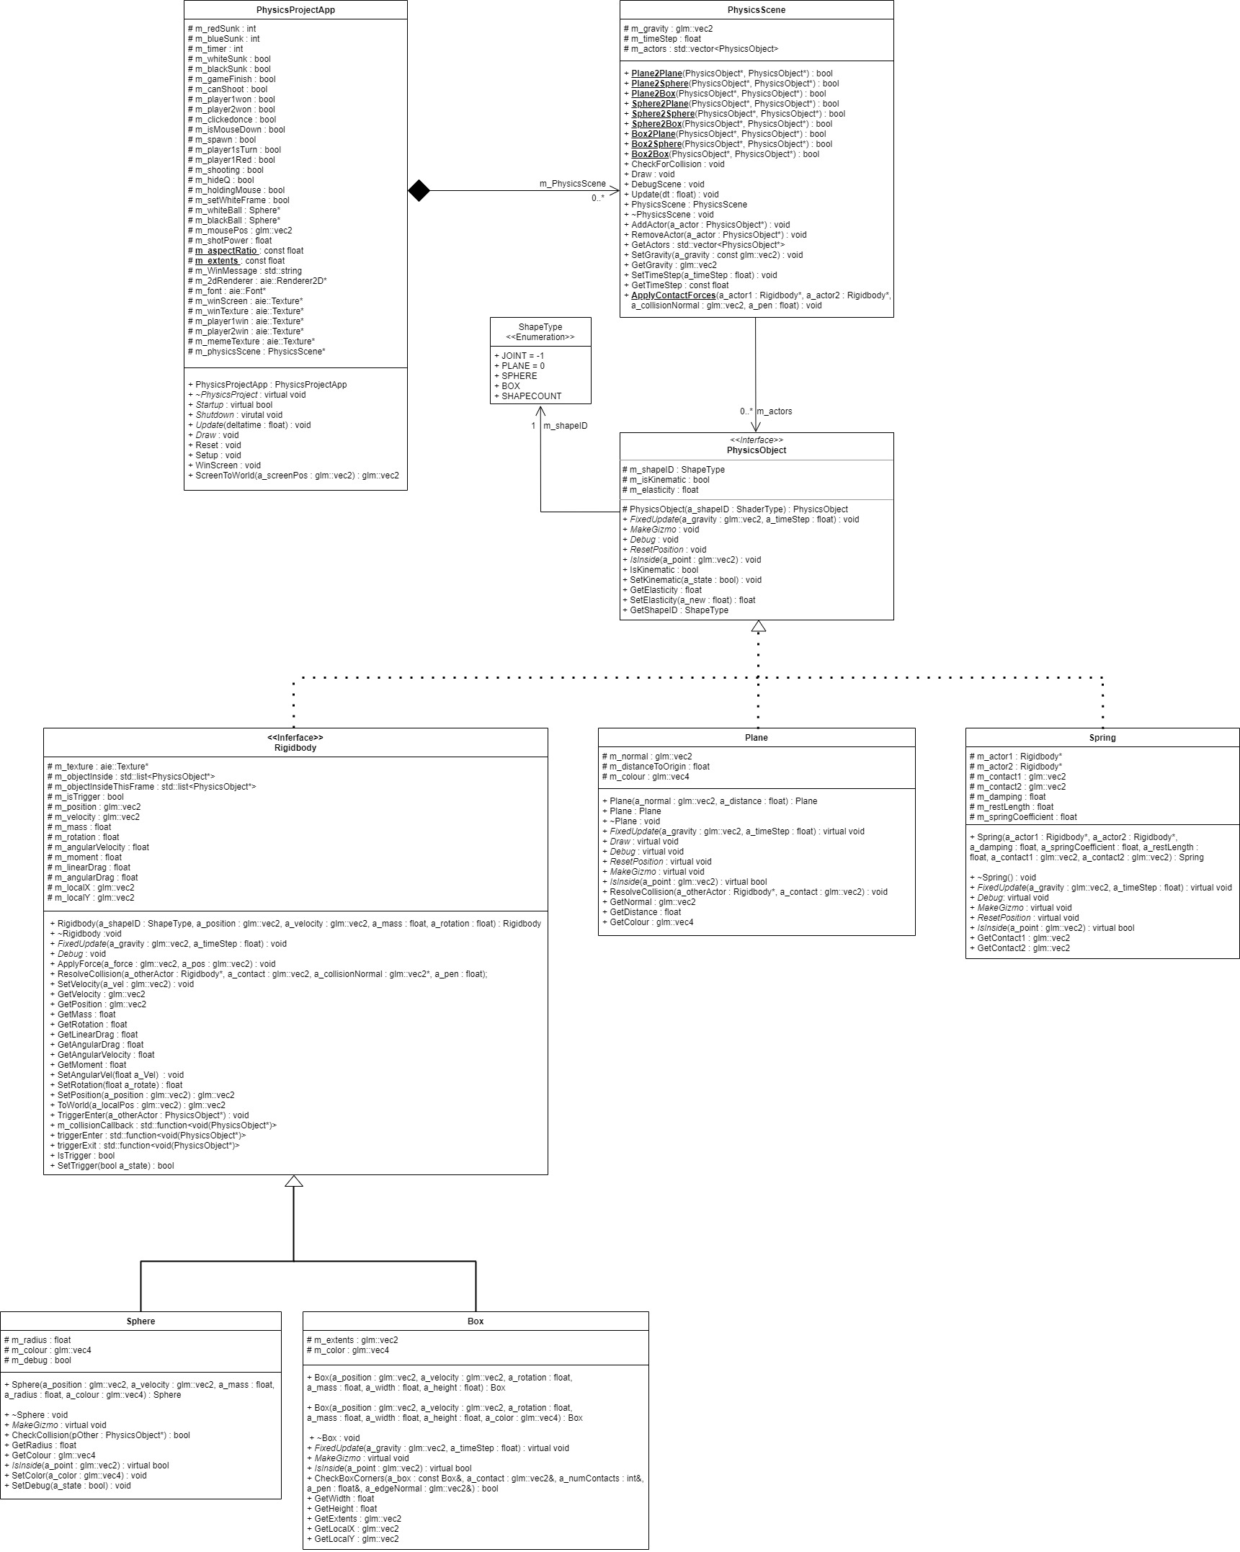
UML DIAGRAM:

